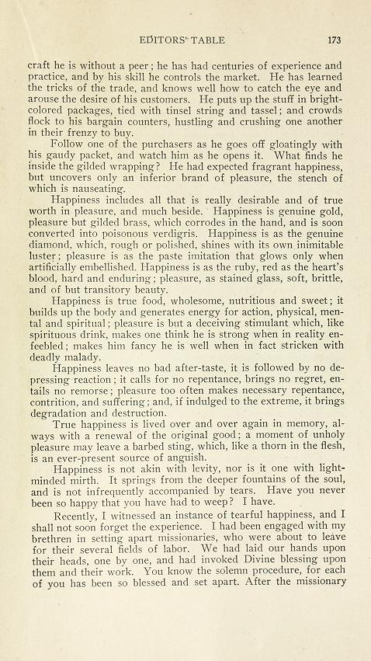
Paradigm Shift with the 9 Dots- Connect using 4 lines

The Way to Happiness – A common sense guide to better living. Non-profit
Show video, Give Booklet

Song about Smile – Christian song https://www.youtube.com/watch?v=15V2sXSJ8Co

