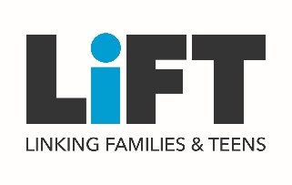

TESTIMONIALS

“This program has taught me to be open to communicate about the ‘tough stuff’ with my girls. My daughter now comes to me with questions or experiences and I listen with an open mind, no judgment. I greatly appreciate how this LiFT program has helped open up the communication in my family.” LiFT Parenting Adult.

“My mom and I always fight about me spending time with my boyfriend. After LiFT, we were able to use the skills that we learned to agree on a decision we both felt good about without fighting. It was such a nice change!”
~LiFT Teen

“We talk more since we participated in LiFT. I learned that it is ok to be nervous to talk to my kids about topics around sex, and now me and my teen are more open to talking about these things. We are more open about sex and have been able to talk about preventing pregnancy and drug use.” ~LiFT Parenting Adult

“It’s helped my adult and I gain more confidence in one another. I feel like I got to know more about them and now I know I could trust them with anything.” ~LiFT Teen

Research shows that a strong parent-child relationship is a superpower that helps teens achieve their goals, and supports healthy teen outcomes, including:
- Decreased rates of unwanted teen pregnancy, STIs, depression, and drug and alcohol use.
- Increased school success.

Parents and teens alike say that they feel uncomfortable and ill-equipped to have conversations with one another about difficult topics, and this makes building strong connections very challenging.

LiFT (Linking Families and Teens) is a new program offered by Planned Parenthood to help families share their values, build the family bond, and talk about the tough stuff – including sexual health and healthy relationships. LiFT includes an engaging and interactive 6-hour workshop, one follow-up phone call, and 12 weekly text messages for both teens between the ages of 13-19 and their parenting adult*.

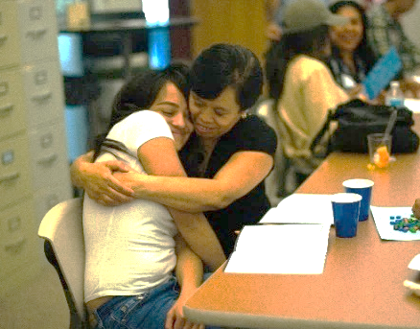

IMPACT
In qualitative data collected at the booster call, three- and 12- months following the program, youth and parenting adult participants say they are having more tough talks, and credit LiFT with building their confidence and skills to have conversations around sexuality and relationships; helping to increase trust between family members, and to be more open and empathetic with one another.

These results are supported by the preliminary data from 3- follow-up surveys, which show that, compared to survey-only participants**:
- LiFT youth communicate more frequently about sexuality values, thoughts & feelings with their parenting adult;
- LiFT adults communicate more frequently about sexuality and pregnancy with their youth;
- LiFT adults report having a stronger relationship with their youth than survey-only adults; and
- LiFT youth are more likely to feel competent preventing pregnancy.

WANT TO LEARN MORE? Contact Meagan Niebler at Meagan.niebler@ppgnhi.org for more information.

*Parenting adult can include biological parent, foster parent, caregiver, grandparent, aunt or uncle, or another important adult in the life of that teen. **These results include participants living in rural communities of 50,000 or fewer.

