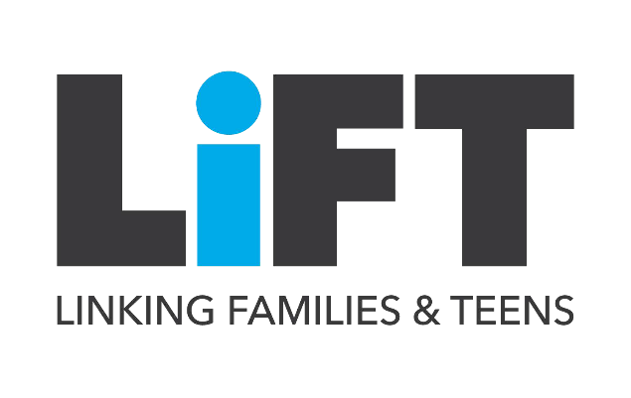
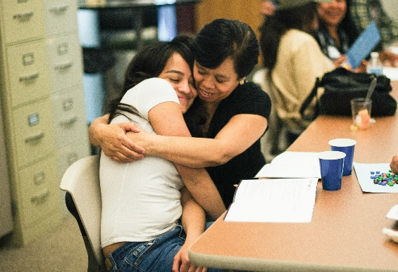
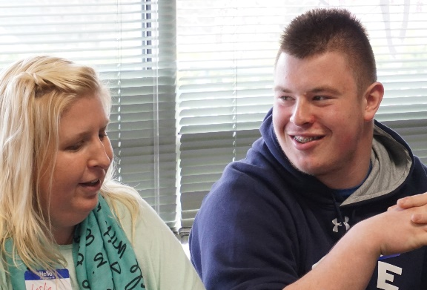
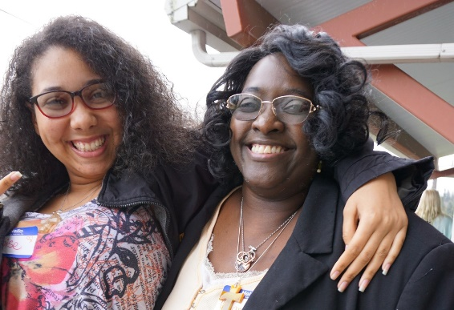
IS IT EVER HARD TO CONNECT
WITH YOUR TEEN
about their values and making healthy choices?

Linking Families and Teens is a free 6-hour program that brings teens (ages 13-19) and their supportive adult(s)* together to learn how to share family values, strengthen family bonds, and talk about the tough stuff – like sexual health and relationships.
- Encourage your teen to open up to you
- Support your teen to achieve their goals
- Help your teen make healthy choices
- Connect with other parenting adults in your community
October 16th from 10:00 - 4:00pm

*Supportive Adult is any parent, caregiver, grandparent, aunt or uncle, or other important adult in the life of a teen.

Questions? Want more information?
Register: https://tinyurl.com/28c3ezjb
Contact: Kaleigh Bronson, kaleigh@canyoncreekservices.org

LiFT was developed by Planned Parenthood of the Great Northwest and the Hawaiian Islands and was supported by Award No. TP2AH000026 from the Office of Population Affairs (OPA). Its contents are solely the responsibility of the authors and do not necessarily represent the official views of OPA or HHS.

