STEP #1 Go to schools.shmoop.com; Click Pink Button: Go
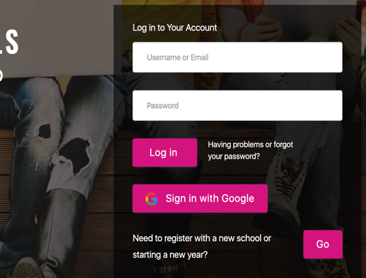 STEP #2 Enter FLATTOP in the blue box (look below)
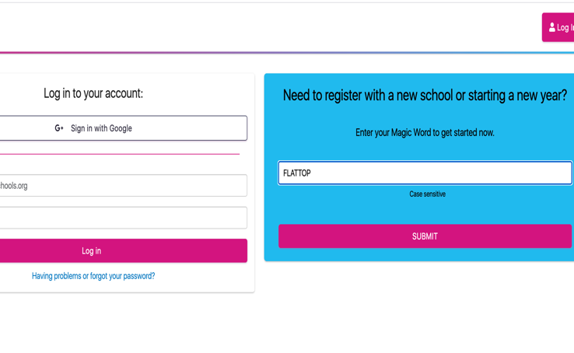
STEP #3 Find Launch High School and click on the link
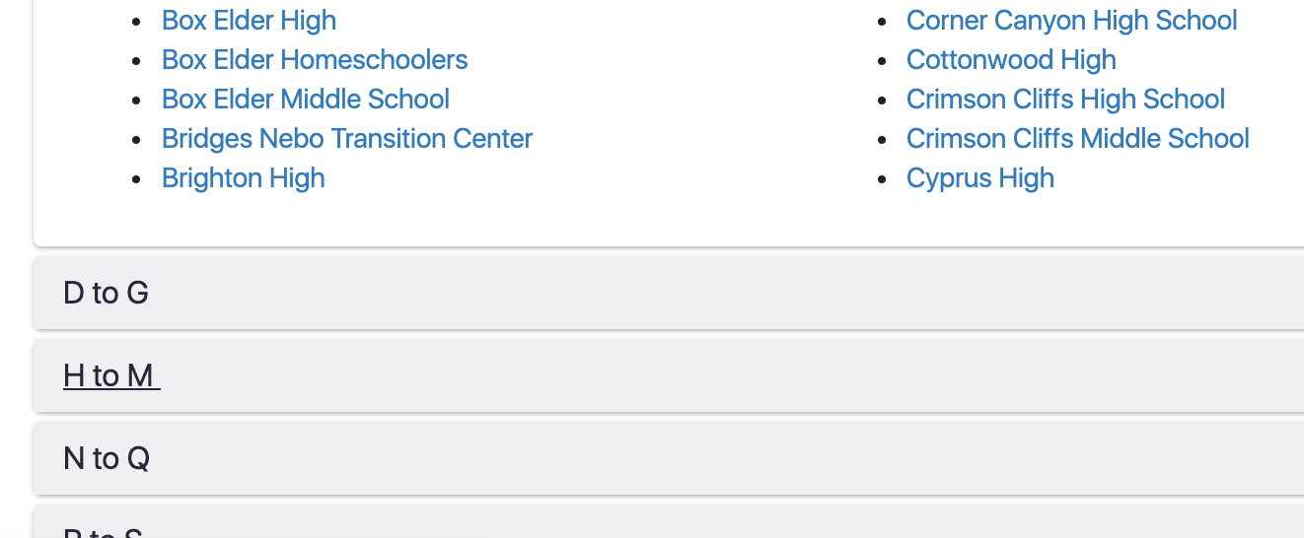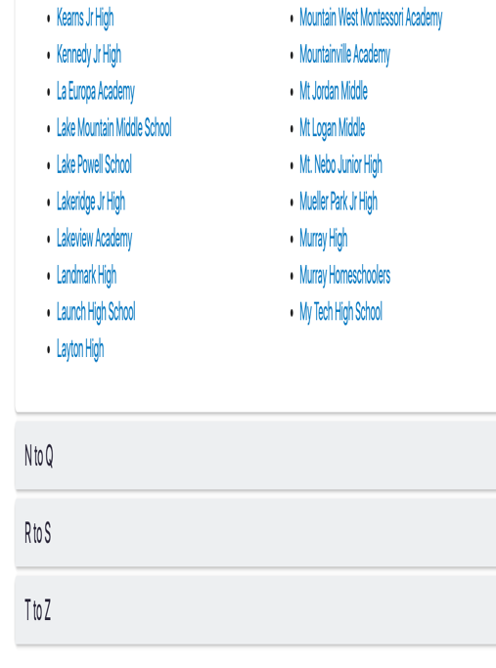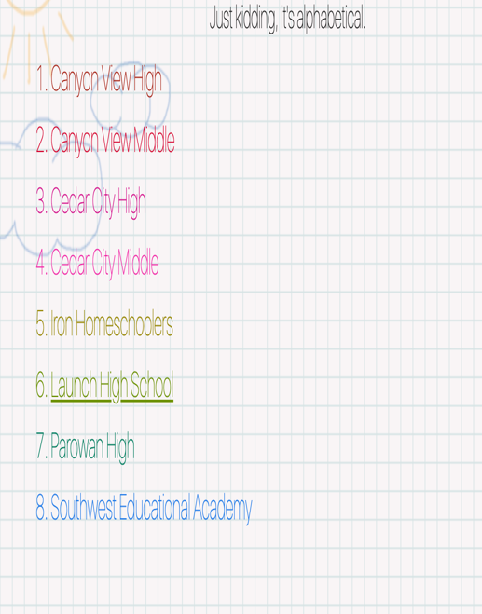
STEP #4 Log-in or create an account if you are new
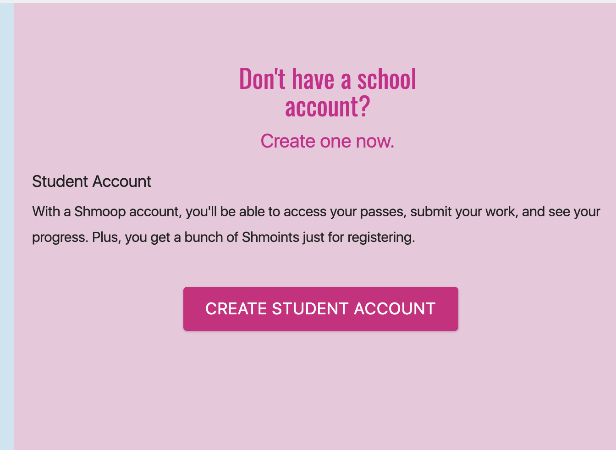

STEP #5 Fill out the general information, password, and security answers.

STEP #6 HOME PAGE Landing Page- Click on All My Test Preps
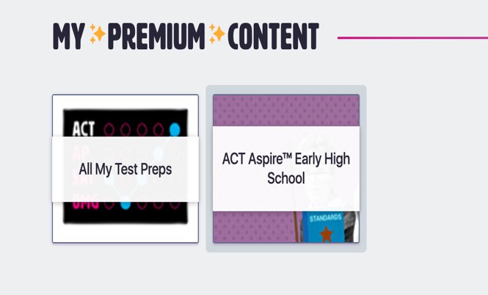
These are grade-leveled preparation tests for the ACT.
-8th is the Aspire Test -9th is the Explore Test. -10th is the Plan Test
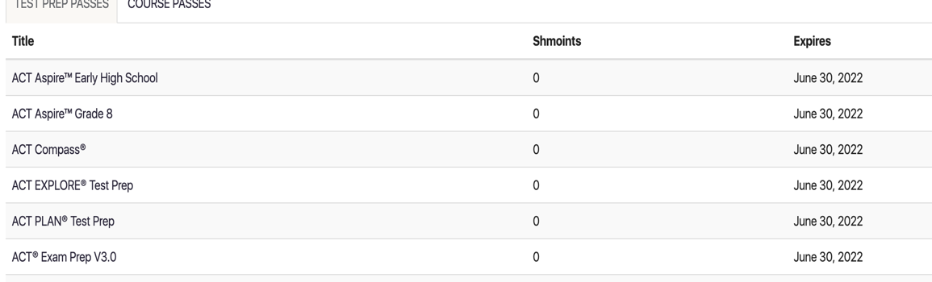

Below is an Example of 9th grade EXPLORE Test
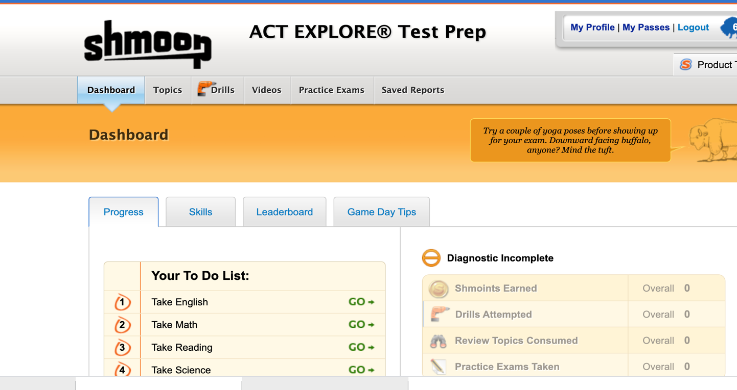

Step #7 To take practice ACT, SAT, or AP tests, find tab on the right entitled Schools and Beyond